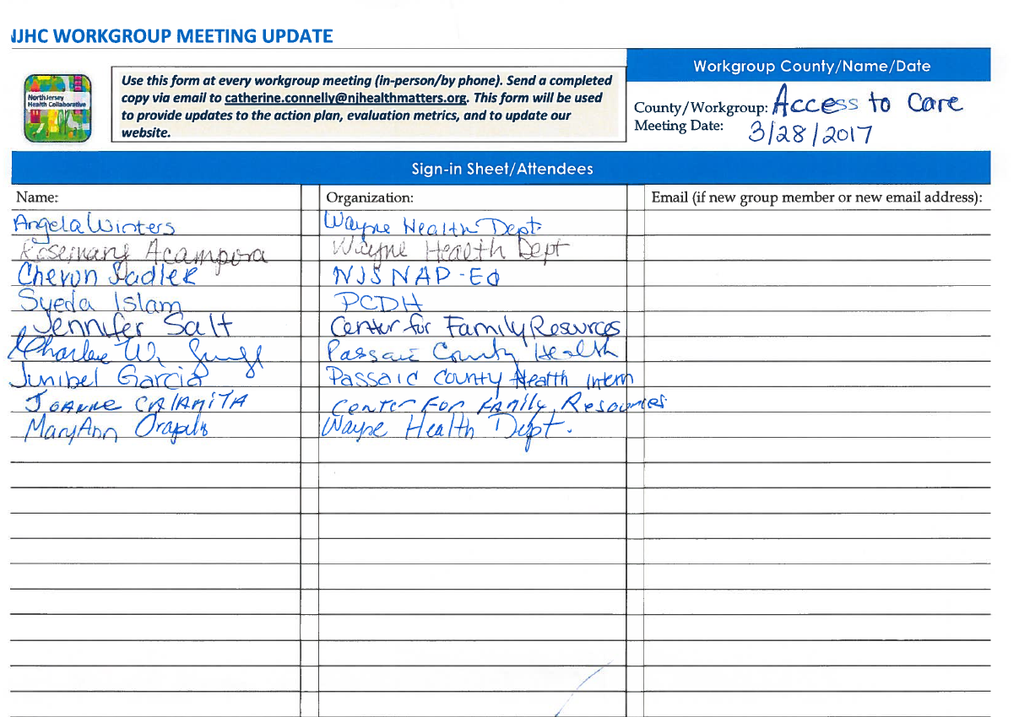
Actions Taken Since Last Meeting:

Action/By Who:

* Call to Order: Dr. Charlene W. Gungil called meeting to order at 9:12 am.
* Approval of minutes: Motion to approve meeting minutes from February 27, 2017 first by Jennifer Salt, second by Joanne Calamita
* Subhi Abugosh from Passaic County Department of Health continued to work on updating the referral directory.
* Jennifer Salt from Center from family resources researched the process of translating a language.
* Junibel Garcia from Passaic County Department of Health entered 245 completed surveys into SPSS software for analysis.

Need to Make Updates to Action Steps (Identify Action Step being revised or mark as NEW)

Action/By Who/By When:

*No need to make updates to action steps.

Need to Make Updates to Strategies or Metrics

____ Yes _X__ No If yes, please list updates below:

Need Data, Research or Technical Support

_____ Yes ___X_ No If yes, please specify need: ___________________________________________________________

Key Decisions, Notes, Meeting Summary:

The access to health care workgroup team held their monthly meeting on March 28, 2017 from 9:00am -11:00am at the Wayne Department of Health. The workgroup collected a total of 248 completed surveys as of 3/28/2017 and will continue to collect surveys until 04/07/2017. Jennifer Salt will invite Orietta (a Spanish Translator) to our next meeting. Syeda Islam will reach out to Jewish Family Services to administer surveys. She will reach out to Michael Hodge to find out his update for strategy 4. Also, she will forward the completed referral directory to the workgroup once it is completed by Subhi Abugosh. Junibel Garcia will continue to analyze data as well as collect completed surveys during Passaic County Health Equity Forum. She will have the analysis ready by April, 26, 2017. The workgroup was invited to the county meeting which will take place on Wednesday, April 26, 2017 from 9:00am - 11:00 pm at the Wayne Department of Health. Also, the workgroup was invited to the Passaic County Health Equity Forum which will take place on Friday, April 7th, 2017 at the Wayne Public Safety Academy.

Next Workgroup Meeting (Date, Time, Place): Tuesday, May 16^{th,} 2017 from 9:00am -11:00 am, Wayne Department of Health: 475 Valley Rd, Wayne, NJ 07470

