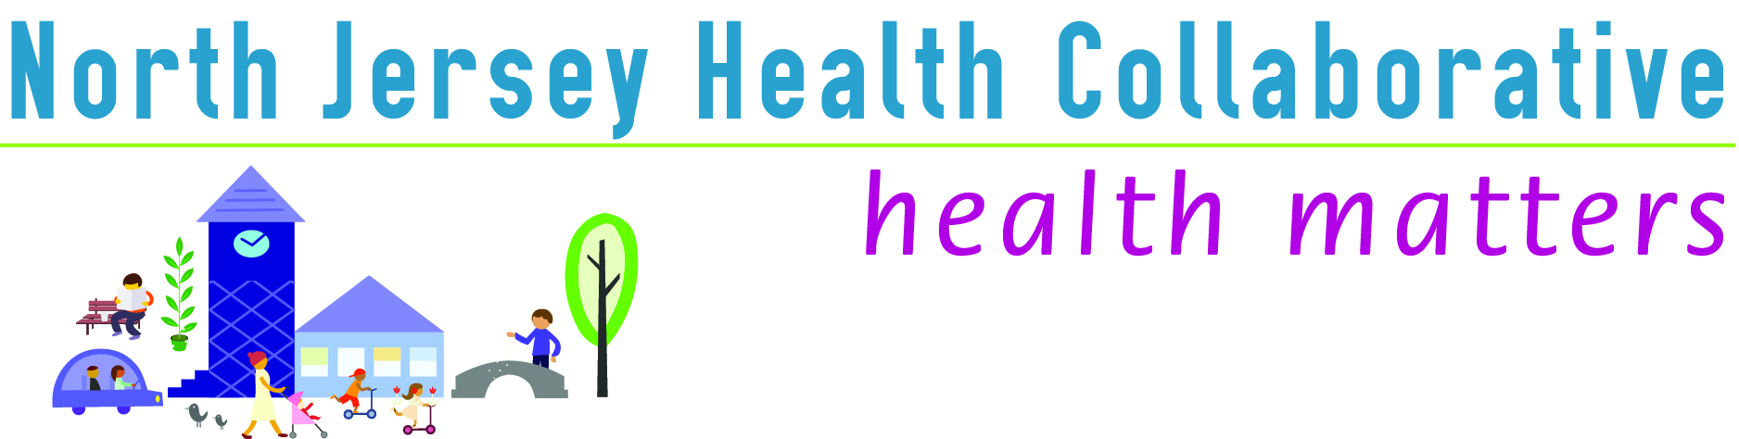
The North Jersey Health Collaborative (NJHC) is an independent 501(c)(3), and self-governed multisector partnership of more than 150 organizations working together to improve the health of our communities in five counties of NJ including, Morris, Passaic, Sussex, Union and Warren County. Join the movement as a NJHC Partner and help us create significant and meaningful change in the health of our communities.
Why should my organization partner with the NJHC?

- If you believe that we are better together than we are apart.
- If you need better data to perform your work.
- If you want to deploy resources more efficiently.
- If you want to bring more shared funding to propel us toward mutual goals.
- If you want to learn from and collaborate with other leaders in the field.
- If you want your organization to be recognized as a leader in the community.

What is a NJHC Partner? Organizations or individuals committed to collaboration for collective impact in improving community health. Partners agree to work with the NJHC on data collection, prioritization and planning, program support, and by contributing in-kind resources to support the work of the collaborative.

What is a NJHC Funding Partner? Partner organizations that provide financial support and governance of the NJHC.

Partner Benefits
- Voting position on NJHC Committees to give voice to the
concerns of the populations you serve.
- Recognition and promotion on our website: www.njhealthmatters.org
- Opportunity to be nominated and elected as a Committee Chair.
- Access to shared data, evidence based practices, and resources,
including technical assistance and support from our Data Committee.
- On-going networking and collaboration with other community leaders.
Additional Exclusive Benefits for Funding Partners
- Voting position on NJHC Board of Trustees.
- Prominent recognition on our website and all printed materials, including Supporter, Transformer or Catalyst designation.
- Opportunity to be nominated and elected to serve as an Officer of the NJHC.
- Access to exclusive professional development opportunities.
- Promotion and spotlight in our NJHC newsletter.
Partner Responsibilities
- Participate in a local county committee or workgroup, and/or NJHC Regional committees for data, communications & marketing, and programs.
- Contribute to the collective impact of the NJHC by offering in-kind resources including staff time, community programs, and data sharing in support of the needs assessment and community health improvement plan.

NJHC Mission: Building Capacity to Improve Community Health
Vision: Healthy Communities – Healthy People

