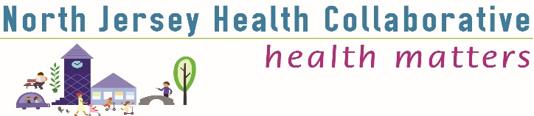
Warren County Community Health Improvement Coalition
Warren County Library – Headquarters Branch
Time: 10:00 -12:00 am
Date: February 1, 2018

Meeting Minutes
Welcome and Introductions | Peter Summers, Chair WC CHIC
NJHC Collaborative News  - Funding Campaign & New Committees  - Professional Development Plan 2018  - Partner Survey & Website Survey Results | Catherine Connelly, NJHC
Community Voice Survey  - The survey originated from suggestions from collaborators and partners.  - The survey fills the gaps about health, such as residents’ overall perception of safety in their community.  - This survey is designed based on the County Health Rankings and Roadmap Model.  - It is available in English, Spanish, and Arabic.  - Incentives for participants include: 3, $100 gift cards raffled off for each county and the “grand prize” (maybe?) of a JETs signed football  - So far, 300 people have taken the survey and 40 organizations have signed on to distribute the survey.  - It takes about 10-20 minutes to complete the survey.  - People will not be able to take the survey again once it has been opened on that device (computer, phone, etc.). However, organizations that will be using their own devices for people to complete their surveys will be given individual org links to distribute.  - The survey will close at the end of April.  - Anyone who attended this meeting (02/01) has received training to distribute the survey at their organization. | Data Committee: Ashley Anglin, AHS and Sarah Perramant WC HD  - Members were asked to take the survey as community members and to sign up their organization to administer the survey. Organizations can sign up at goo.gl/ET7seG  - Survey distribution instructions should be followed to protect data integrity and confidentiality.  - Surveys collected on paper should be directed to the Data Committee at www.njhealthmatters.org ; the Committee will enter the data.
County Health Improvement Plan: Progress Reports and Q&A  - Access to Care- Pete reported that the Access to Care strategies are completed. He will send them to Catherine to be placed on the website.  - Substance Use (Coalition for Safe &Healthy Communities)- MaryJo reported that the coalition is focusing on access and availability to drugs due to the higher usage rates among individuals who have more accessibility and availability to substances.  - Tobacco Control- Sarah reported that the age of sale has changed to 21. MaryJo added that they are looking to focus on making parks smoke-free throughout the county.  - Chronic Disease (Sussex-Warren CD Coalition) - Lea reported that the chronic disease coalition is focusing on cancer and putting together a care coordination team to better focus on cancer patients.  - Nutrition (Shaping NJ) - Sarah reported that we did not receive the Shaping NJ grant this year. However, they would still like to complete the farmer’s market this year and we still own the kayaks at White Lake for the moonlight paddle. The group is looking for new members to join.  - Violence Prevention (DASACC Warren County) - Matt reported that they created an impact statement. The group is focusing on Warren County residents learning about resources for domestic violence. Sexual Assault Awareness Month is in April and the organization is planning many events. | Facilitated by Peter Summers  Reports by:  Peter Summers, WCHD  MaryJo Harris, Coalition for Safe and Healthy Communities  Sarah Perramant, WCHD  Lea Kimmelman- Norwescap CEED  Matt Hardy- DASACC
County News & Networking
- Sharing events, resources, programs.
- WC Addictions Awareness Task Force will provide information about resources on May 4th. The group meets the 3rd Thursday of every month at Rutgers Cooperative Extension. Meetings are open to the public.

Next Meeting April 5th
10:00 A.M. – 12:00 P.M. at the Warren County Library Headquarters Branch

