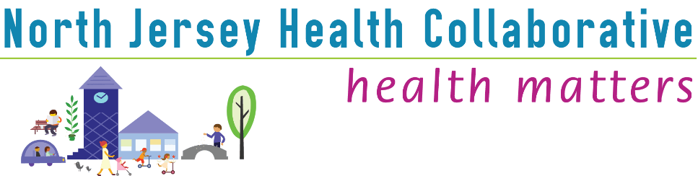

10/5/2021
Passaic County Committee Meeting Minutes
North Jersey Health Collaborative
Meeting called to order at 3pm by Cathy Scutti.
CHNA Review
The Final Draft of CHNA was presented to the group with a discussion on the following focus areas:
Healthy Aging, Mental Health and Substance Use, Maternal Child Health, Chronic Disease and Cancer.
Executive Director asked for support from public health and community partners by aligning organizational missions and work with the goals of the upcoming Community Health Needs Assessment to capture impact data
The results of the social determinants of health were shared.
There will be a special 30-minute meeting of each committee to address to CHIP process in preparation for January 2022.

Meeting Adjourned at 3:30.

