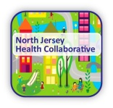  Use this form at every workgroup meeting (in-person/by phone). Send a completed copy via email to catherine.connelly@njhealthmatters.org. This form will be used to provide updates to the action plan, evaluation metrics, and to update our website. |  |  | Workgroup County/Name/Date
County/Workgroup: Sussex/Substance Use Disorders
Meeting Date: September 30, 2016, October 6, 2016
Sign-in Sheet/Attendees
Name: |  | Organization: |  | Email (if new group member or new email address):
Annmarie Shafer |  | Center for Prevention and Counseling
Jodie Luker |  |  |  | jodieluker@yahoo.co.uk
Becky Carlsom |  | Center for Prevention and Counseling
Tina Aue |  | Center for Prevention and Counseling
Nick Loizzi |  | Substance Abuse Coordinator/Municipal Alliance Coordinator

Actions Taken Since Last Meeting:

Sep. 9, 2016: September CFPC Coalition Meeting: 16 ppl attend w/agenda including Oct. 6 instructions & promoting Oct 22, “National Rx Take Back Day.”
Sep. 27, 2016: 8 ppl attend training in Florham Park by Partnership for a Drug-Free NJ to understand work on 10/6/16, “Knock Out Opiate Abuse Day.”
Sep. 30, 2016 8 Volunteers pick up materials for distribution to medical professionals and community at large on Oct. 6, 2016
Oct. 6, 2016 Volunteers and coalition staff distributed new CDC guidelines to ~ 135 physicians, in Sussex & Warren Counties.
Oct. 10, 2016 provided training for 30 school nurses from Sussex, Morris & Warren counties on addiction, opiates and Narcan administration.
Oct. 11, 2016: Newton P.D. brought Mobile Rx disposal box to local subsidized housing complex where ~20ppl disposed of unwanted Rx medications.
Oct. 14, 2016: October CFPC Coalition Meeting; 18 ppl reviewed success of Oct 6 activities and discussed following up with physicians
Nov. 10, 2016: sent follow-up letter to 60 prescribers encouraging continued contact to receive info. re: addiction, treatment and recovery resources
Nov. 11, 2016: met with staff of Dr. Storch, Vitolo & Siegfried, Sparta delivering additional CDC guidelines and Rx disposal site posters
Nov. 30, 2016: Met with Zufall Medical Center Manager and staff, Newton, (followed-up w/email re: CDC guidelines, PMP and Rx disposal sites.)
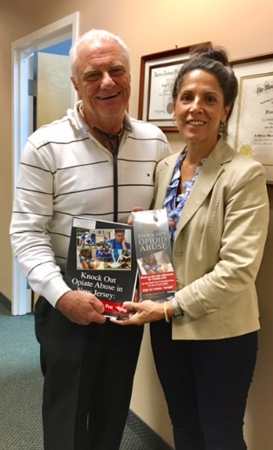
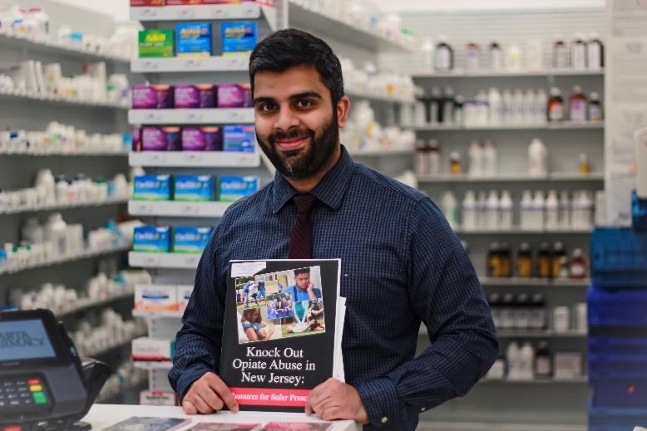
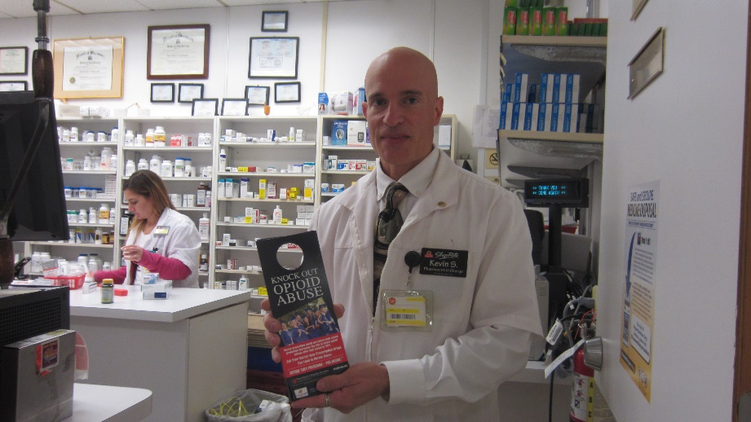

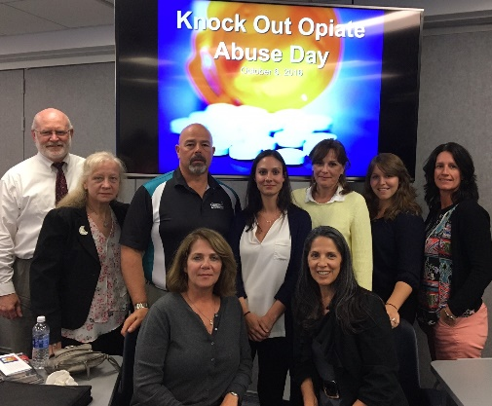

Need to Make Updates to Action Steps (Identify Action Step being revised or mark as NEW)
Strategy 1 & 2 Action Step 4. Do No Harm Symposium confirmed w/ Atlantic Health; NMC Romano Conference Center; April 6, 2017

Action/By Who/By When:

Need to Make Updates to Strategies or Metrics

____ Yes _____ No If yes, please list updates below:

Need Data, Research or Technical Support

_____ Yes _____ No If yes, please specify need: ___________________________________________________________

Key Decisions, Notes, Meeting Summary:

Next Workgroup Meeting (Date, Time, Place): ____________________________________________________________________________________

