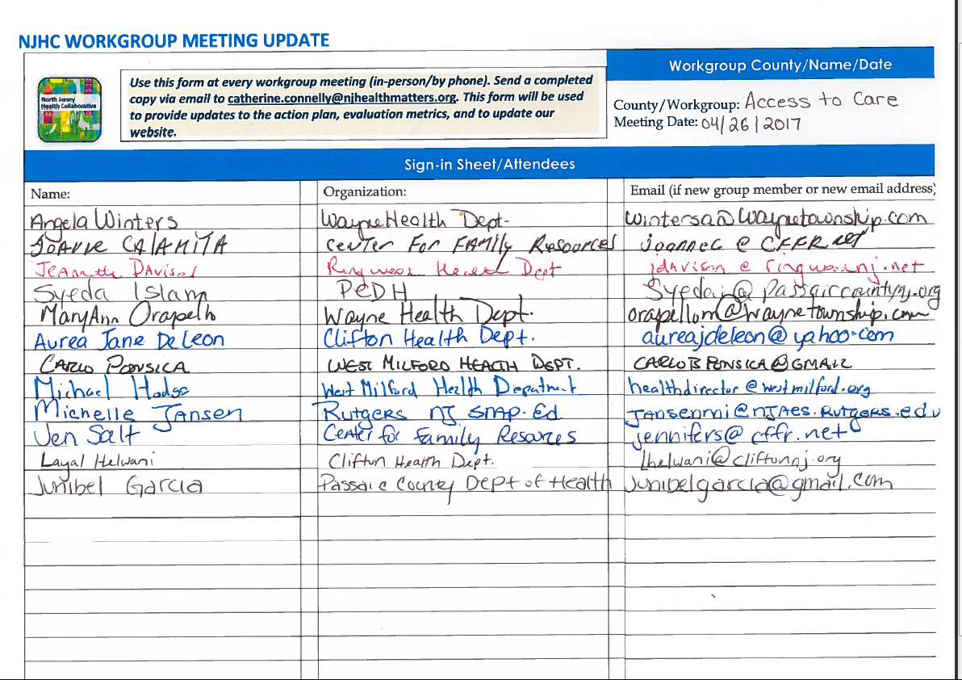
Actions Taken Since Last Meeting:

Action/By Who:

* Surveys was distributed to Jewish Family Center in Clifton by Syeda Islam, Passaic County Department of Health.
* 245 surveys was analyzed by Junibel Garcia, Student Intern from Passaic County Department of Health.

Need to Make Updates to Action Steps (Identify Action Step being revised or mark as NEW)

Action/By Who/By When:

*No need to make updates to action steps.

Need to Make Updates to Strategies or Metrics

____ Yes __X__ No If yes, please list updates below:

Need Data, Research or Technical Support

_____ Yes __X___ No If yes, please specify need: ___________________________________________________________

Key Decisions, Notes, Meeting Summary:

The access to health care workgroup attended the NJHC county committee on April, 26, 2017. The workgroup will continue to work on the following prior to the next meeting:

* Invite language translator by Jennifer Salt, Center for Family Resources.
* Research the process of MOU by Michael Hodges, West Milford Health Department.
* Any additional completed surveys must be scanned/email to Syeda Islam, Passaic County Department of Health.
* Prepare survey analysis presentation by Junibel Garcia, Passaic County Department of Health.
* Resend/Email referral directory to all member of the workgroup by Syeda Islam, Passaic County Department of Health.
* The workgroup will review/edit referral directory list by May 12, 2017.

Next Workgroup Meeting (Date, Time, Place): _____May 16th 2017, 9:00am-11:00am, Wayne Department of Health___

